**ASSESSMENT-1**

**NAME: MOHAMMED ZHOEB**

**STUDENT ID: 00287693T**

**SUBJECT: SYSTEM ANALYSIS AND DESIGN (MIS605)**

**LECTURER: NAZRUL PRAMANIK**

**Table of contents**

1. **Introduction**
2. **Question 1 (stakeholders and list of stakeholders and actors)**
3. **Question2 (major functional requirements)**
4. **Question 3( non-functional requirements)**
5. **Question4 (use case diagram)**
6. **Question5 (use case elaboration)**
7. **Conclusion**
8. **References**

**Introduction:**

The below report usually summarizes the major functional requirements of the case study of online student enrolment followed by the non-functional requirements which include user interference, easy to use, tolerance of faults, access permissions, adaptable to various technologies. It also gives description of the particular use cases providing its description and proposing the case diagram for the online enrolment process.

**Question 1:**

**Stakeholders:**

Stakeholders might be an individual or organization or it can be a group which might have keen interest in an organization. By the company’s policies or objectives they might be affected or affect the organization.

**Two types of stakeholders:**

1. **Primary stakeholders:** These are referred as an internal stakeholders who are directly involved in the transactions related to the economy of the organization. Example of such stakeholders includes customers, employees, creditors, suppliers etc.
2. **Secondary stakeholders:** These are referred as an external stakeholder who are not directly involved in the economic transactions of the company but might get affected by the company’s decision. Example of such types are media, support groups, communities etc (Gaur, 2013).

**List of stakeholders and their importance:**

|  |  |
| --- | --- |
| **Stakeholders** | **Importance** |
| Students | Enrollment in subjects |
| Student enrollment officer | Manual enrolment system/ allocates study load to students |
| Pro – vice chancellor | Contemplate online enrolment system |
| Program director | Provides subject selection criteria |
| Time tabling officer | Creates and edit the timetables for each subject |

All the above stakeholders usually come under as a primary stakeholder of the company as they are involved internally for the organization. They have direct effect on the organization. They are the most important aspect which is involved in the development of the projects.

**Actors:**

Actors are the specific bodies who interact with the system to achieve the goals. They can be the customer, external services, humans or organization etc ("Getting Started With Use Case Modeling", 2007).

They are classified into two types:

**Primary actors:**

These are the stakeholders that depend on the system for its goal to be delivered. It doesn’t always trigger the use case.

**Secondary actors:**

They are the reactionary one who provides service to the system. Which includes web services or humans etc ("Types of Actor in a Use Case Model", 2020).

|  |  |
| --- | --- |
| **Primary actors** | **Secondary actors** |
| Students | Student enrolment officer |
|  | Pro-vice chancellor |
|  | Program director |
|  | Time tabling officer |

In the report provided students act as primary actor as they uses the system to achieve the goal like subject enrollment and fee payments etc.

Whereas the secondary actors like student enrollment officer, pro-vice chancellor, program director, timetabling officer which provides service to the system to on go the project of online student enrollment system.

**Question 2:**

**Functional requirements:**

It is defined as a basic behavior of the system which includes data input, calculations and various business processes. The behavior includes functions which are necessary for the system or services etc. It allows the system to function in a way which is intended to do. If the system failed to meet the requirements it doesn’t work (Malan & Bredemeyer, n.d.).

**The functional requirements of the case study:**

1. The system should allow the student enrolment officer to make the changes like edit, delete the core or elective subjects in the courses offered.
2. The system should be accessible through the various devices like tablets, desktops etc.
3. The system should only allow program director to update the details regarding the course and subject pre requites.
4. The new system should allow the timetable officer to make any necessary changes in the subject timetables.
5. Subject selection should be available with the list of subjects offered for its selection by the student.
6. The system should prevent the subject and timetable clashes
7. The system should allow the students to select the subjects based on the study load provided by the student enrolment officer
8. System should provide a customized table specifying the location and class timings
9. The system should provide a secure payment process for the fee payment.
10. The system should provide a report to the officers regarding the number of students enrolled.

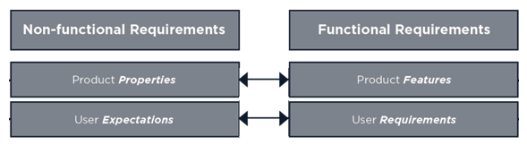

**Question 3:**

**Nonfunctional requirements:**

It usually specifies how the system should function. The criteria of the nonfunctional requirements are even not met the system will function without any possible interactions. It defines the how the features and characteristics might affect the experience of the user. It mostly judge on the properties of the product, its performance and expectations of the user ("Functional vs Non-Functional Requirements: The Definitive Guide - QRA Corp", 2020).

**Some of the nonfunctional requirements of the case study:**

**User interface appearance:**

The design of the system should be basic including the university logo making more attractive to the students. Decent colors should be used making it more elegant rather than using the flashing colors. It should reflect the study environment.

**Easy to use:**

The system design should be understandable to the user and provide necessary information when the user commits the error. It should have an option to undo the changes within the system rather than doing the whole process again. The system should prompt the double time check option to save the changes; this will be mostly helpful during the subject selection for the student.

**Tolerance of the faults:**

Sometimes due to unexpected system crash or shut downs might result in the loss of data or changes that have been made within the system. The system should store all the changes during this type of unexpected happenings. Making their work available whenever they make login with their respective ids.

**Access permissions:**

The student should be provided by the secure access to their logins. The access should be granted using the unique identification number and passwords. The higher authorities like timetabling officer and student enrolment officer should be able to access the each part of the system.

**Adaptable to various technologies:**

The system should be adaptable to various web browsers and should be easily accessible in the various devices like tablets, desktops, laptops. It should be compatible with the various operating systems like mac, windows, Ubuntu etc.

**Question 4:**

**Use case diagram:**

Use case diagram depicts the performance of the system in achieving the goal containing the complete information of the system and relationships between the actors and the base case. It consists of various relationships like include, extend and generalised relationships.

**Include relationship:**

It includes the features of the one-use case (base case) with the other (include case)

**Extended relationship:**

It explains the behaviour of one-use case extended in other use case.

**Generalised relationship:**

It depicts how one element of the case diagram is depended upon the other (parent) (IBM Knowledge Center, n.d.).

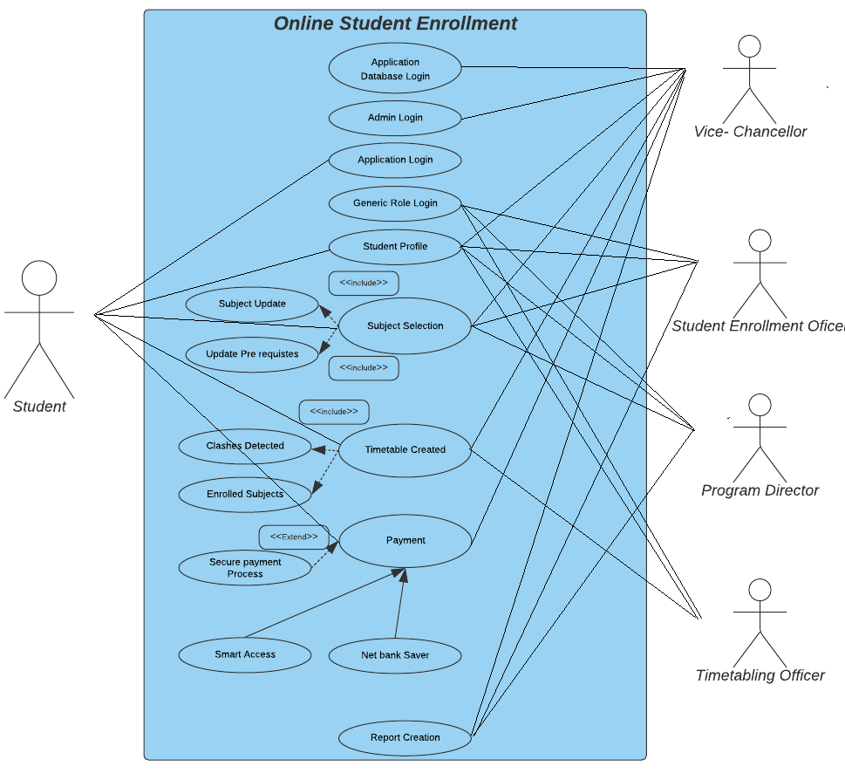

The above use case diagram usually describes the online student enrolment system contemplated by the vice-chancellor of the university. The primary actors involved are student whereas the secondary actors include vice chancellor, student enrolment officer, program director, timetable officer. The main base cases include login, student profile, subject selection, timetable created, payments. All the base cases are been involved with the primary actor. There exists a relationship between the base case and the other cases like included and extended relationship.

The base case like subject selection consists of the included relationship like subject update and pre requisites of the subject. This base case is also related to the secondary actor like student enrolment officer who create, edit the subjects and also allows the selection based on the study load provided.

The base case like time table selection consist of the included relationship like clashes involved and enrolled subject which displays the list of subjects selected. It is also related to the time table officer who updates the subject information and courses.

The base case like payment is also related to the primary actor and it has a generalised relation to the net bank saver and smart access. It also has a extended relation with the payment secure process which doesn’t prompt unless until made it to.

The base case like application data base and admin access is related only to the secondary actor like vice chancellor who holds the complete control. The base case named generic role profile is related to the other secondary actors like student enrolment officer, program director, timetabling officer.

The base case report creation is related to record the number of students enrolled by the program director and student enrolment officer.

Every actor has been provided with the specified role it self like the student enrolment officer is related to the base case like student profile and subject selection where it can create or remove the subjects based on the study load. Whereas the program directors are involved in the update of the course and student profile. It also includes the timetable officers who are related to the base case timetable creation.

|  |  |
| --- | --- |
| **Base case** | **Id** |
| Application data base | 001 |
| Admin access | 002 |
| Login | 003 |
| Student profile | 004 |
| Subject selection | 005 |
| Timetable created | 006 |
| Payment | 007 |
| Report creation | 008 |

**Question 5:**

**Subject selection:**

The base case subject selection provides the option for the students to select the subjects for the study load provided by the student enrolment officer and program director. The student enrolment officer can create or edit the core subjects and can provide the study load to the students based on their study profile.

|  |  |
| --- | --- |
| Use case name | Subject selection |
| Id | 005 |
| Priority | High |
| Actor | Student, student enrolment officer, program director |
| Description | It allows the student to enrol the subjects online from the list of the subjects provided |
| Trigger | Students sign in on their university website by using the student id and password provided and views their profile appropriately. |
| Precondition | Students create a student profile and login into the university website |
| Normal course | Steps.   1. Students create a student profile 2. Subjects are selected by the students which are provided by the student enrolment officer 3. Timetable is created by the system without any clash between the different classes 4. Payment invoice is sent to the student mail 5. Payment options are made available to the student for fee payment. 6. Successful online enrolment of the subjects. |
| Alternative course | Header tab is provided for subject selection |
| Post condition | Students enrol in the subject and successful creation of the time table without any clash is achieved |
| Exceptions | Selection of the subjects should not exceed the minimum or maximum criteria based on the study load provided. |

**Payment:**

The base case payment provides the option for the fee payment. It generates the invoice based on the number of subjects selected. Different types of payment option are made to avail for secure payment which is meant to be successful.

|  |  |
| --- | --- |
| Use case name | Payment |
| Id | 007 |
| Priority | High |
| Actor | student |
| Description | Payment of the fees for the subjects selected in the particular course |
| Trigger | Selecting a particular number of subjects followed by timetable creation. |
| Precondition | Secure payment process for successful fee payment for the students |
| Normal course | Steps.   1. Entering the Bpay details of the student and the university in bank app 2. Selecting the account from which the payment has to be done (net bank saver and smart access) 3. Entering the amount and verifying the details 4. Confirming the payment |
| Alternative course | Providing the credit card details in the payment option in the student portal |
| Post condition | Generating payment invoice and mailed to the student mail |
| Exceptions | Invalid card details and error in the updating the Bpay details. |

**Conclusion:**

The above study depicts the major functional and non-functional requirements and also the case diagram giving the brief description of the two cases which includes its triggers, pre and post conditions followed by the normal and alternative course with some of the exceptions. Giving the insights of some meaningful definitions of the stakeholders, functional and non-functional requirements and also the types of relationships in the case diagrams.

**References:**

Gaur, V. (2013). Understand Your Stakeholders. *International Journal Of Advancements In Research & Technology,Volume 2, Issue1, January-2013*. Retrieved from <http://www.ijoart.org/docs/Understand_Your_Stakeholders.pdf>

Getting Started With Use Case Modeling. (2007). Retrieved from <https://www.oracle.com/technetwork/testcontent/gettingstartedwithusecasemodeling-133857.pdf>

Types of Actor in a Use Case Model. (2020). Retrieved 1 July 2020, from <https://www.visual-paradigm.com/guide/uml-unified-modeling-language/types-of-actor-in-use-case-model/>

Malan, R., & Bredemeyer, D. Functional Requirements and Use Cases. Retrieved from <http://citeseerx.ist.psu.edu/viewdoc/download?doi=10.1.1.436.4773&rep=rep1&type=pdf>

Functional vs Non-Functional Requirements: The Definitive Guide - QRA Corp. (2020). Retrieved 2 July 2020, from <https://qracorp.com/functional-vs-non-functional-requirements/>

Ibm.com. n.d. *IBM Knowledge Center*. [online] Available at: <https://www.ibm.com/support/knowledgecenter/SS8PJ7_9.5.0/com.ibm.xtools.modeler.doc/topics/crelsme_ucd.html> [Accessed 4 July 2020].